Creating Rest API with Database connectivity

Core jdbc

ORM tool like JPA or Hibernate

Spring JPA data

In Core JPA we need to write the code with help of EntityManagerFactory, EntityManager, Transaction and Query.

In Spring JPA data. It provided two interface ie CrudRepository and JpaRepository etc.

These two interface base upon java 8 features. From Java 8 onward interface can contains method with body (default or static) . those interface provide default implementation for dao layer

We need to create normal interface with @Repository annotation and that interface extends CrudRepostiory or JpaRepository interface.

If need any custom query base upon our requirement we can write those query using jpql.

Spring boot project

Starter -🡪 web starter

Starter -🡪 jpa starter

Dependency -🡪 mysql

Starter 🡪devtool (whenever we do any changes it automatically refresh the application)

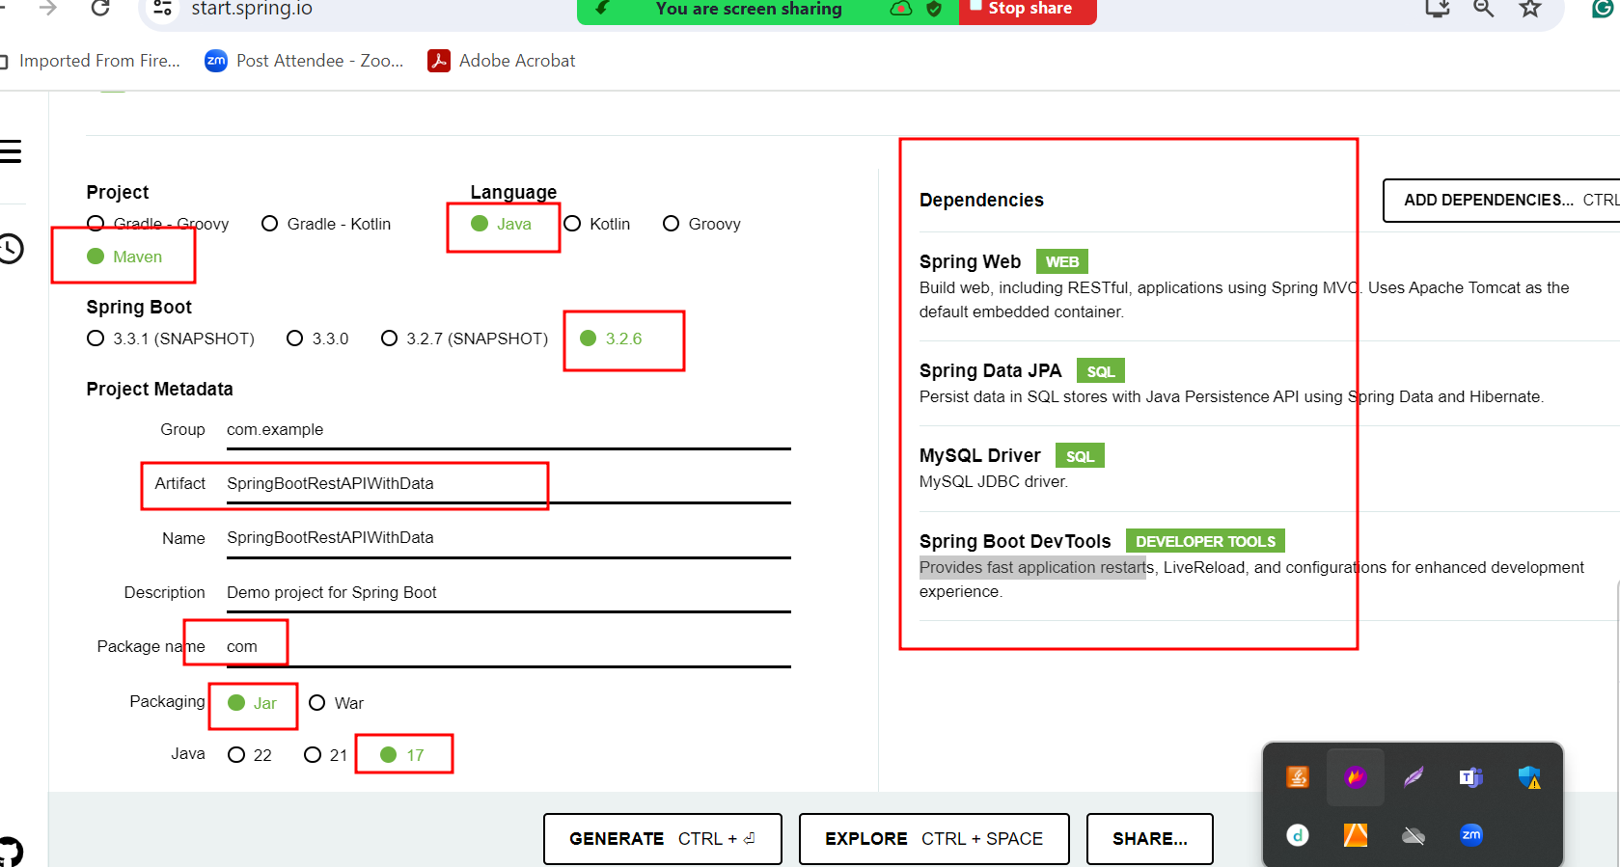

product table --🡪 PID(PK), pname , price etc

100 TV 56000

101 Computer 45000

create table product(pid int primary key,pname varchar(25), price float);

orders -🡪oid(PK), orderdateandtime, pid(FK)

1, 18/06/2024 8:54,100

2, 18/06/2024 8:55,100

3, 18/06/2024 8:56,101

Create table orders(oid int primary key auto_increment, orderdate datetime, pid int, foreign key(pid) references product(pid));